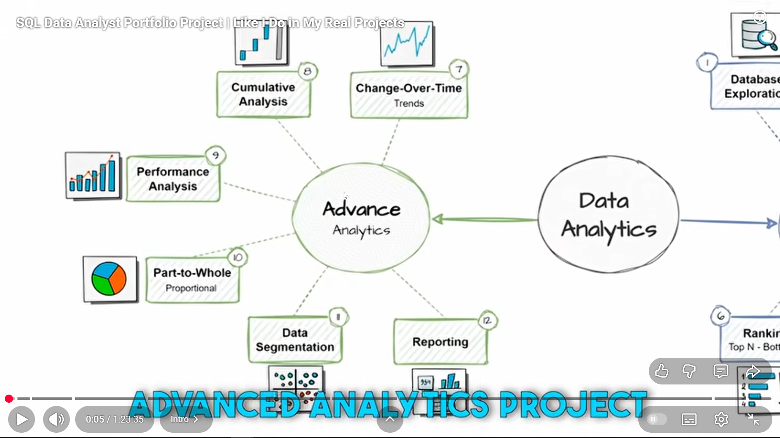

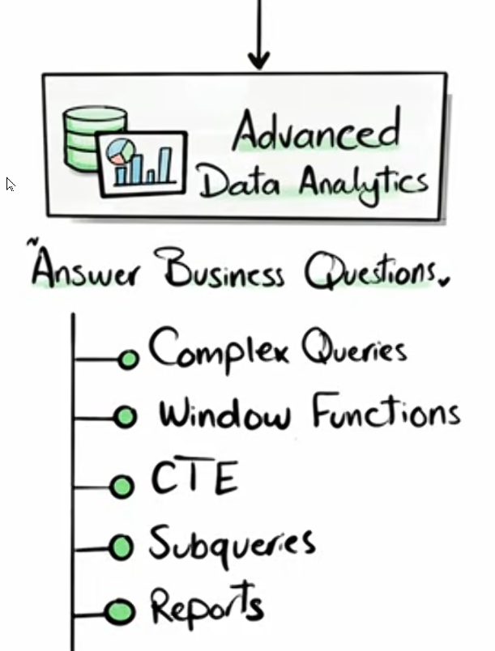

Change Over Time Analysis

===============================================================================

Purpose:

- To track trends, growth, and changes in key metrics over time.

- For time-series analysis and identifying seasonality.

- To measure growth or decline over specific periods.

SQL Functions Used:

- Date Functions: DATEPART(), DATETRUNC(), FORMAT()

- Aggregate Functions: SUM(), COUNT(), AVG()

hjjkjk

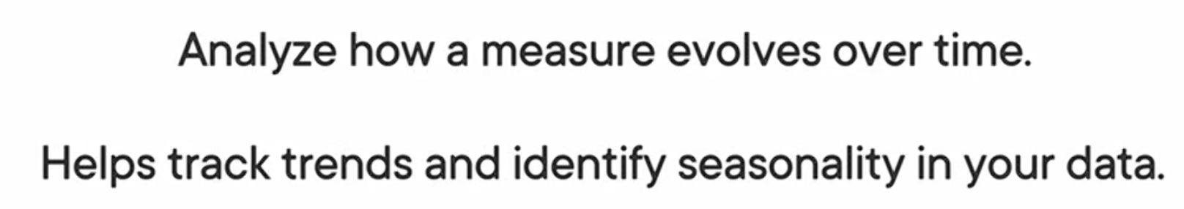



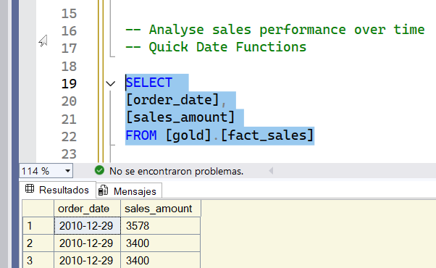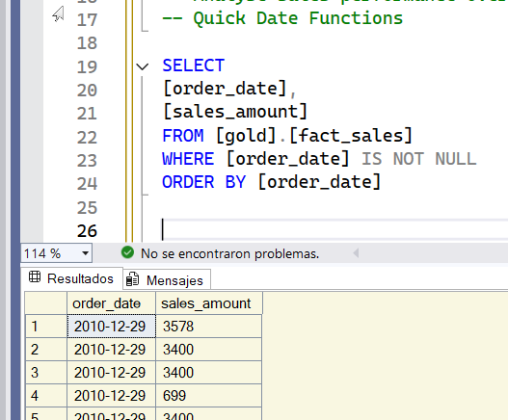

Now we have sales over time. We have a date and we have a measure. Now we are going to aggregate the data by the sales amount.

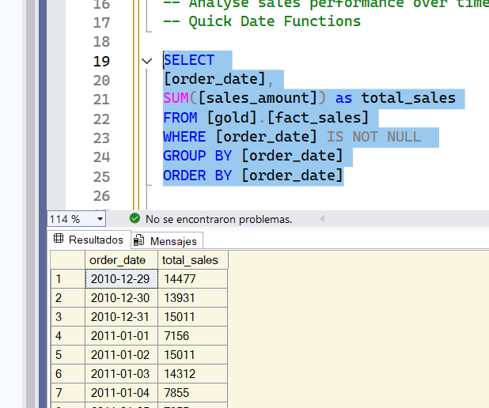

We are analysing the sales over time. But we dont aggregate on the day level. We want to have higher aggregation.

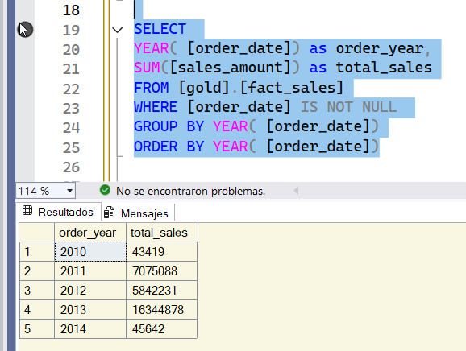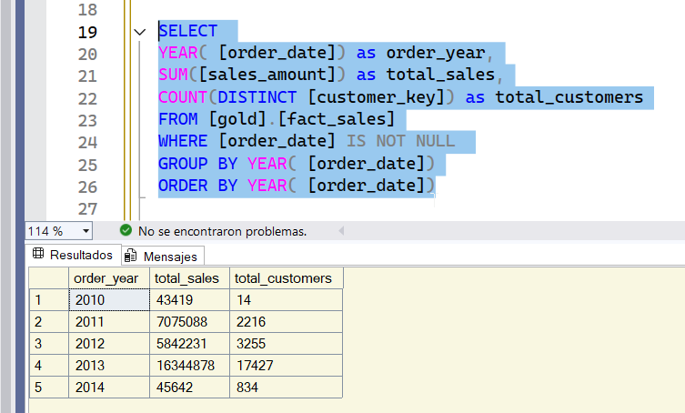

we have changed the aggregation from the day to the year.

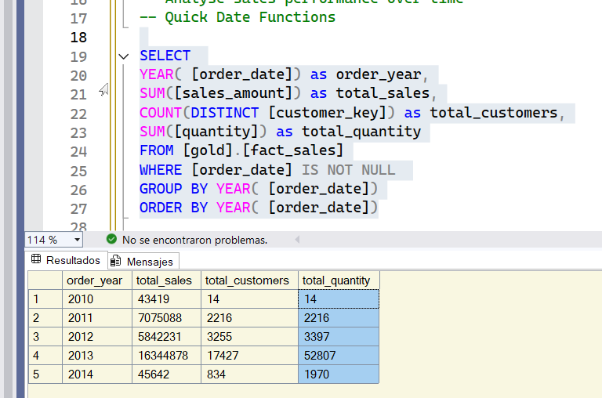

with this we have a nice picture to understand is the revenue increasing or decreasing

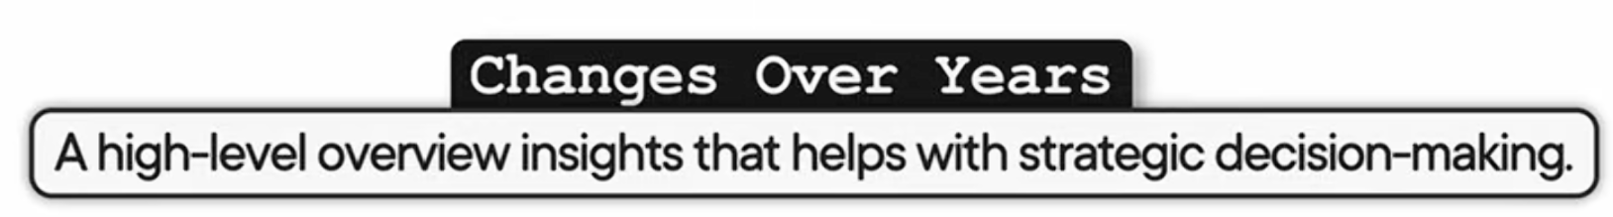

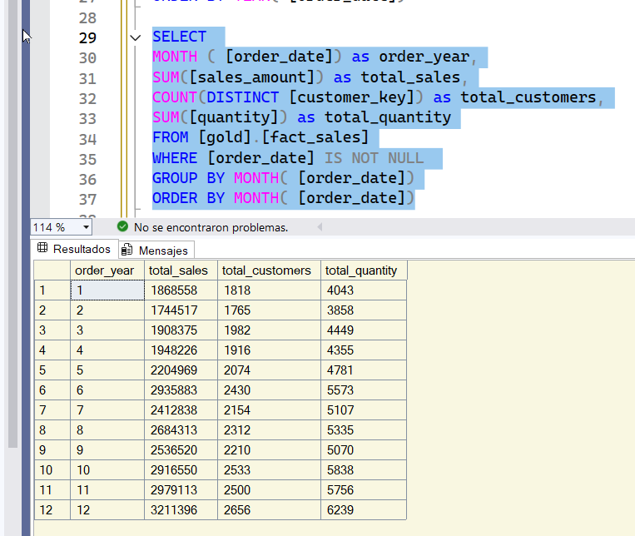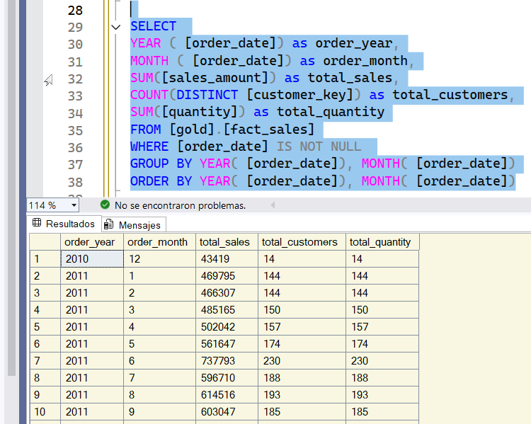

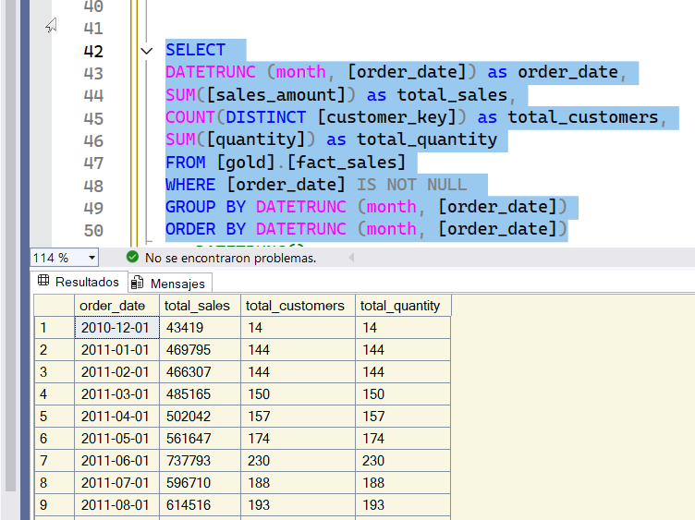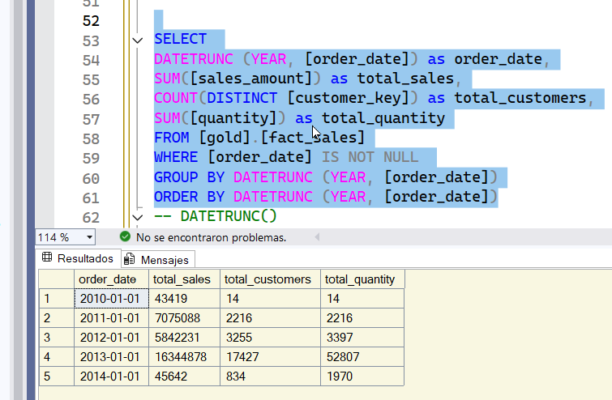

Date trunc

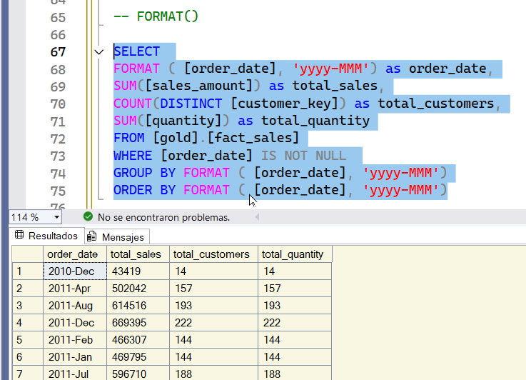

Date Format

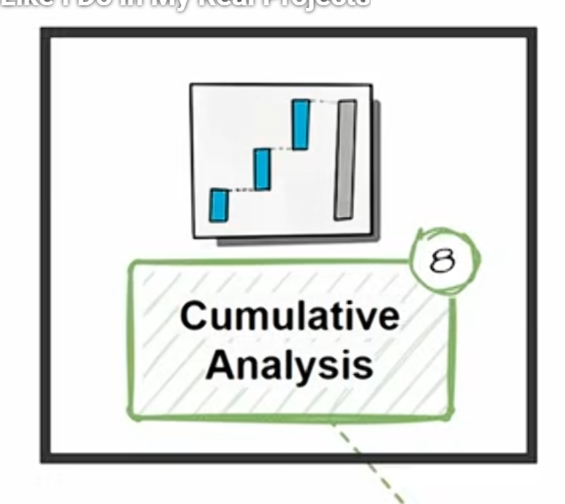







Purpose:

- To calculate running totals or moving averages for key metrics.

- To track performance over time cumulatively.

- Useful for growth analysis or identifying long-term trends.

SQL Functions Used:

- Window Functions: SUM() OVER(), AVG() OVER()

-- Calculate the total sales per month

-- and the running total of sales over time

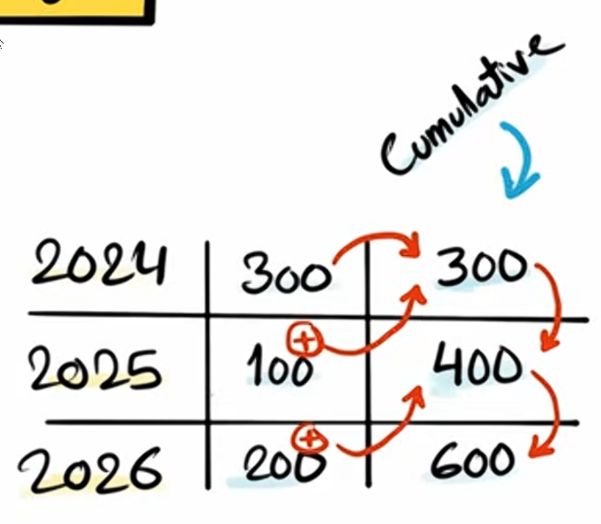

we use Wx Fx

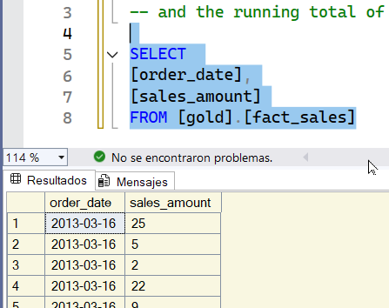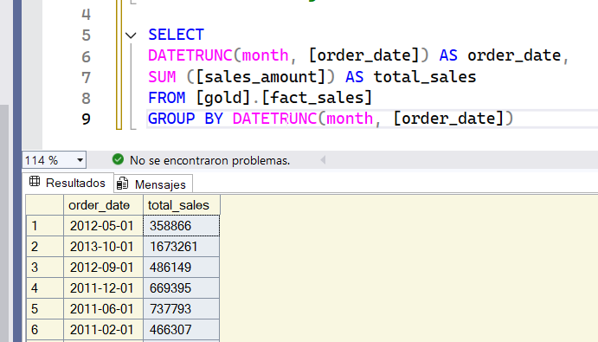

dont forget to get rid off nulls

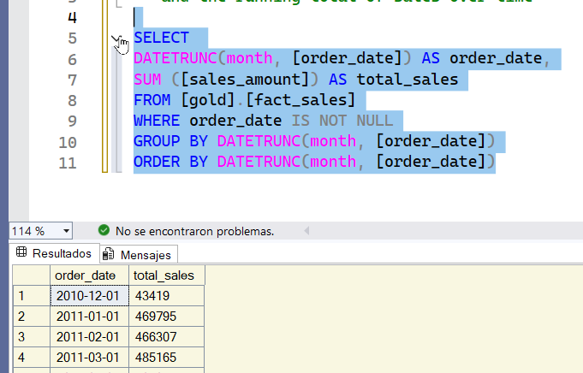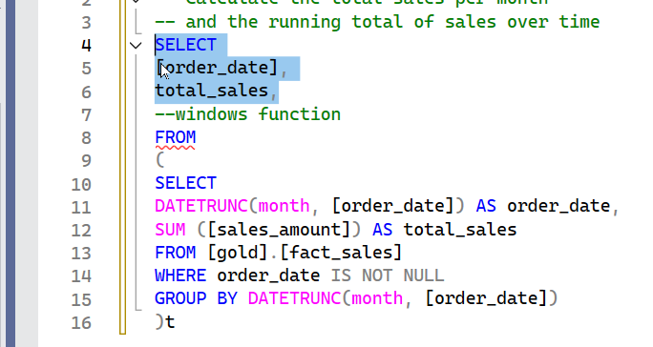

to have cumulative we use wx fx. Now lets start writing our windows function.

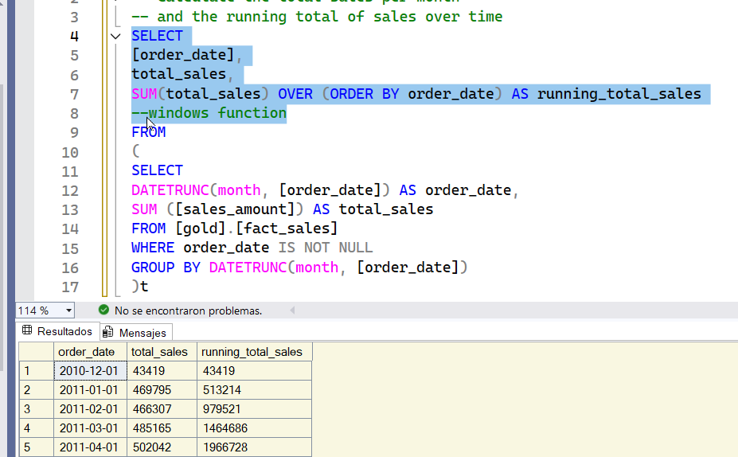



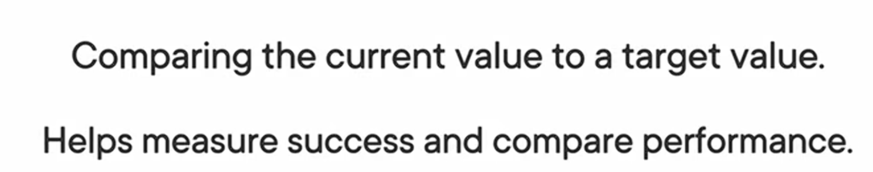

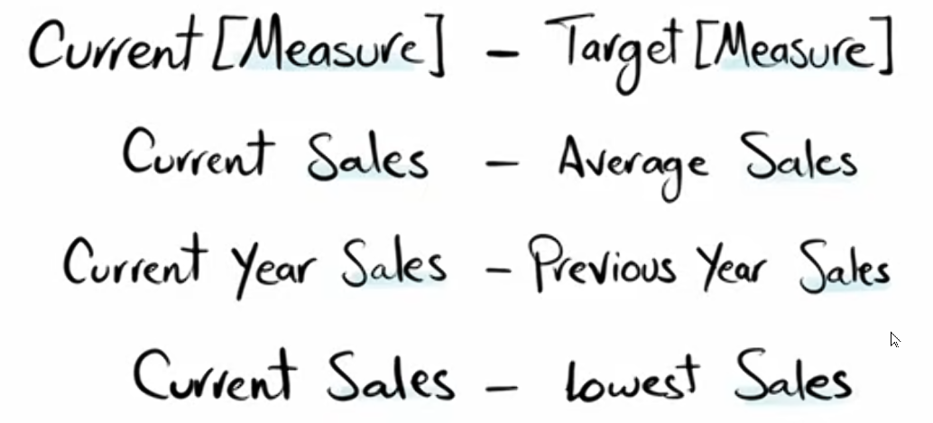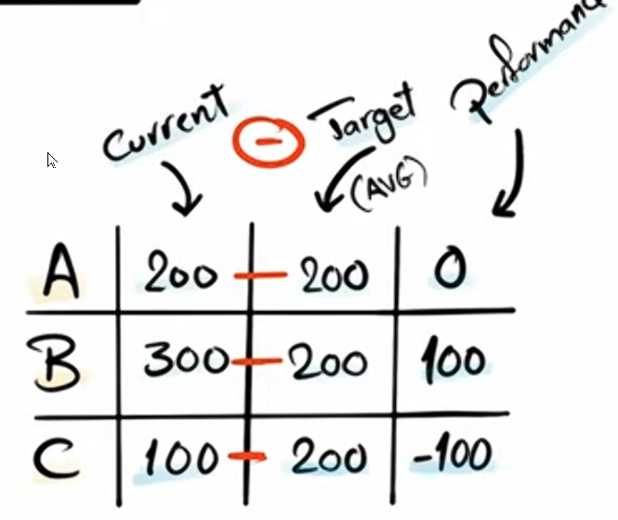

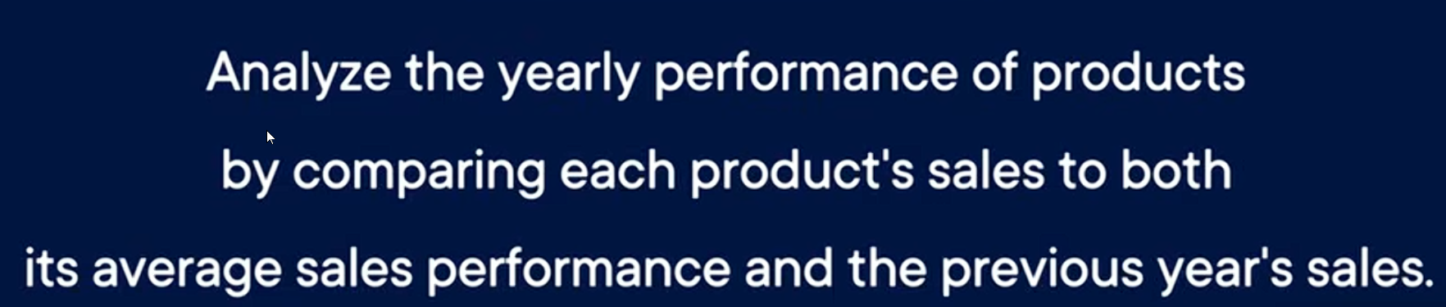

/\*

===============================================================================

Performance Analysis (Year-over-Year, Month-over-Month)

===============================================================================

Purpose:

- To measure the performance of products, customers, or regions over time.

- For benchmarking and identifying high-performing entities.

- To track yearly trends and growth.

SQL Functions Used:

- LAG(): Accesses data from previous rows.

- AVG() OVER(): Computes average values within partitions.

- CASE: Defines conditional logic for trend analysis.

===============================================================================

\*/

/\* Analyze the yearly performance of products by comparing their sales

to both the average sales performance of the product and the previous year's sales \*/

WE need the order date as dimension as well the product and the measure that is here are the sales

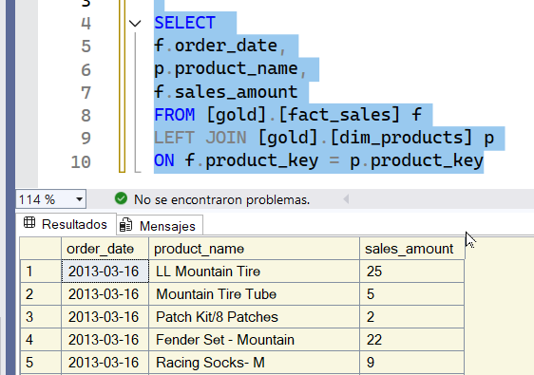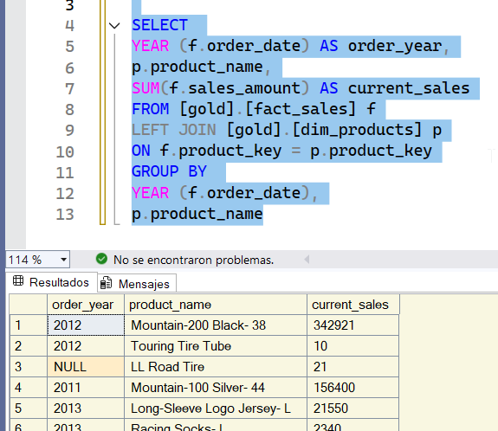

we have to group by the data by date the year and the product name as well. We need to get rid of those Nulls

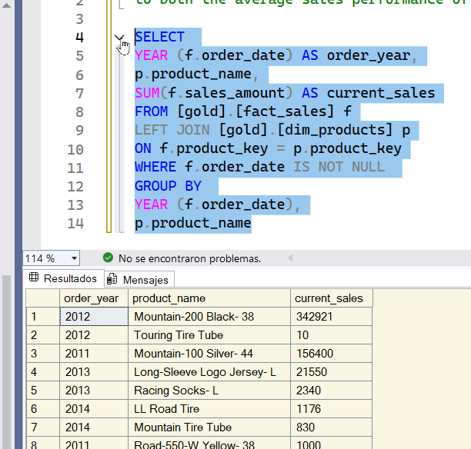

With this you have solved the first part. We have the yearly performance of the products

Now the task ask us to compare the current sales to the avg sales performance of the products. So we NEED the avg and the previous sales of the year. we need to compare each value with the other year.

Lets focus on the avg sales. We are going to use a CTE. We are going to build query on top of this result.

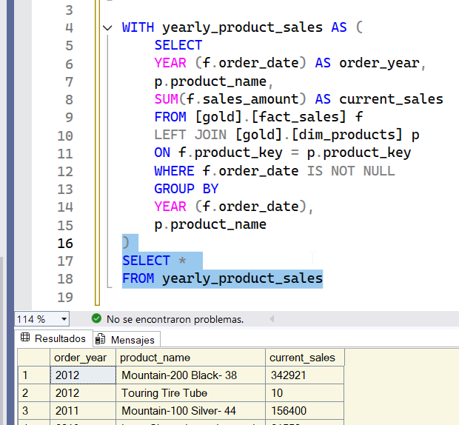

now im selecting the data from our cte next we are going to list all the things we want in our query

then we are going to order the data by product names

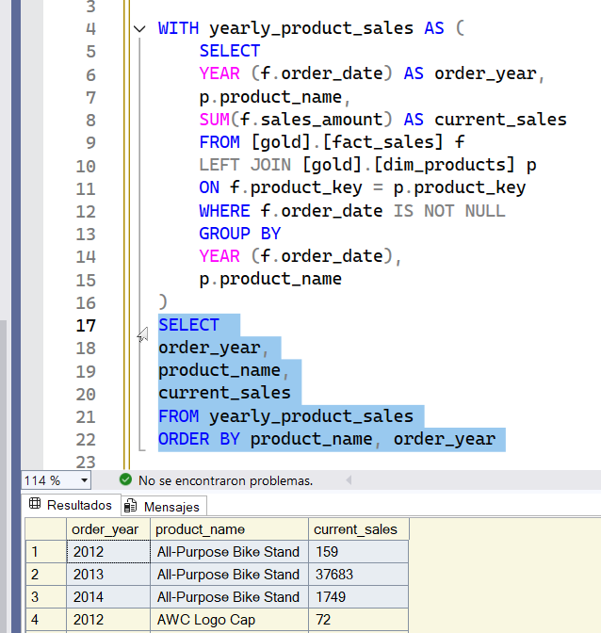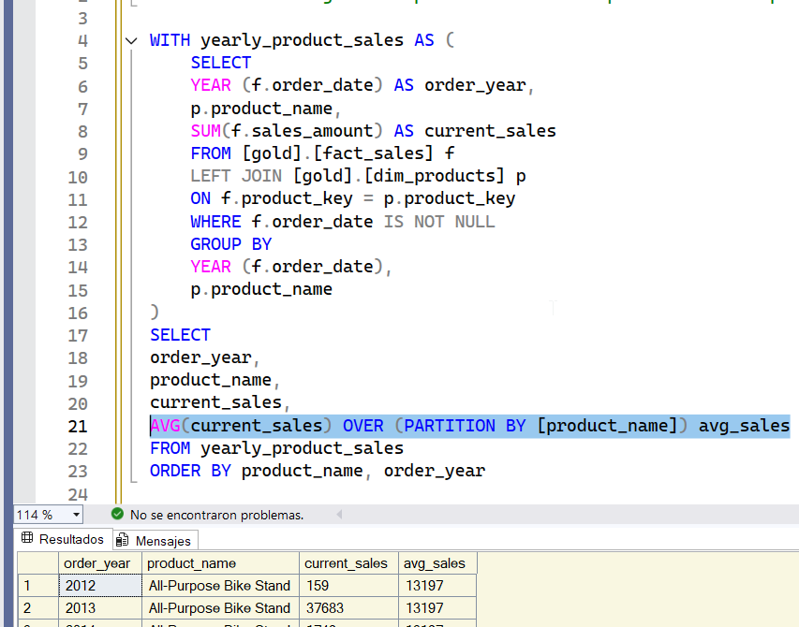

now we need to calculate the avg of those 3 sales. We have to decide how to partition our data. Since we are focusing on our product we need to partition by product name.

For each row we have the current sales and the avg sales. NOw we have to subtract

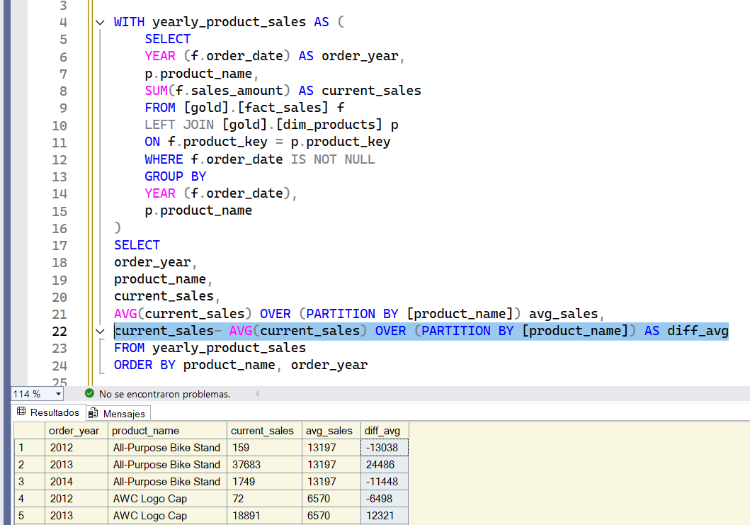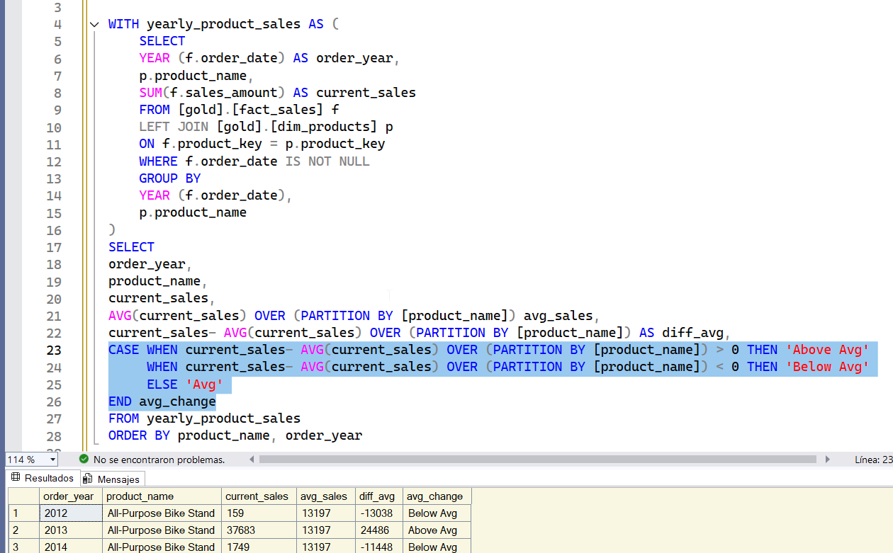

Now we are going to make a flag or an indicator to see if we are over or under the indicator. We use the CASE WHEN to flag.

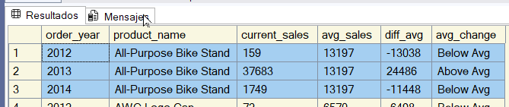

we have a really nice flag. Sometimes we have the same as avg and we have 0

We have compare the current sales with the avg sales performance. Now we have to compare to the previous year sales. now we have to compare the current sales. Not with the avg but with the previous year. We can continue with the same result. We have to access the previous year. For that we have the amazing Wx Fx LAG

We are going to partition by product name

To get the previous value we have to sort the data we need the previous year.

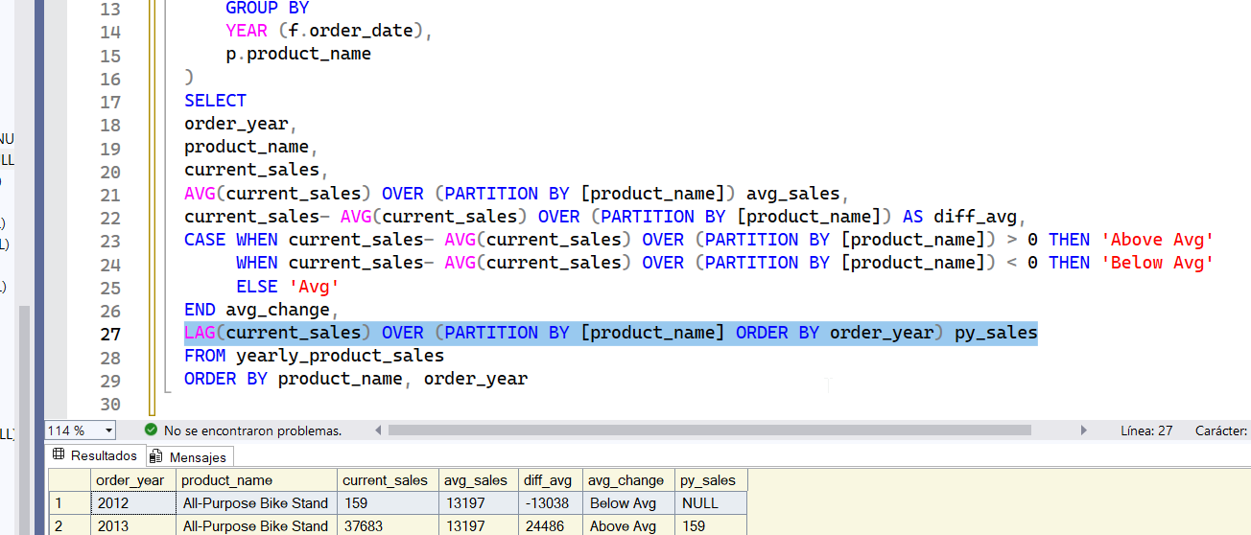

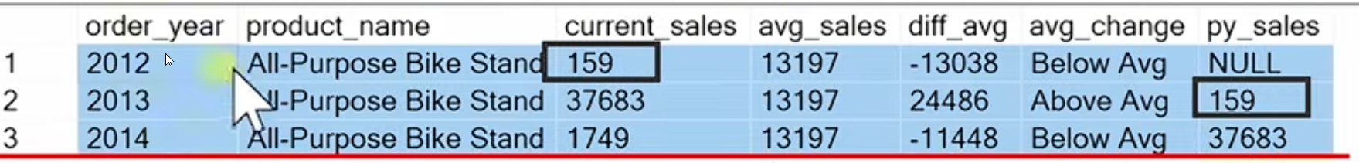

Now we have the previous sales. Now we have to subtract that information. In order to compare them.

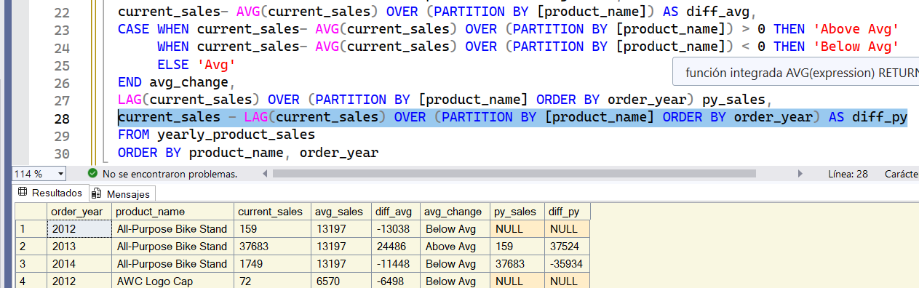

es facil no te preocupes. estamos comparando current sales with previous year. Now we are going to make a flag or an indicator.

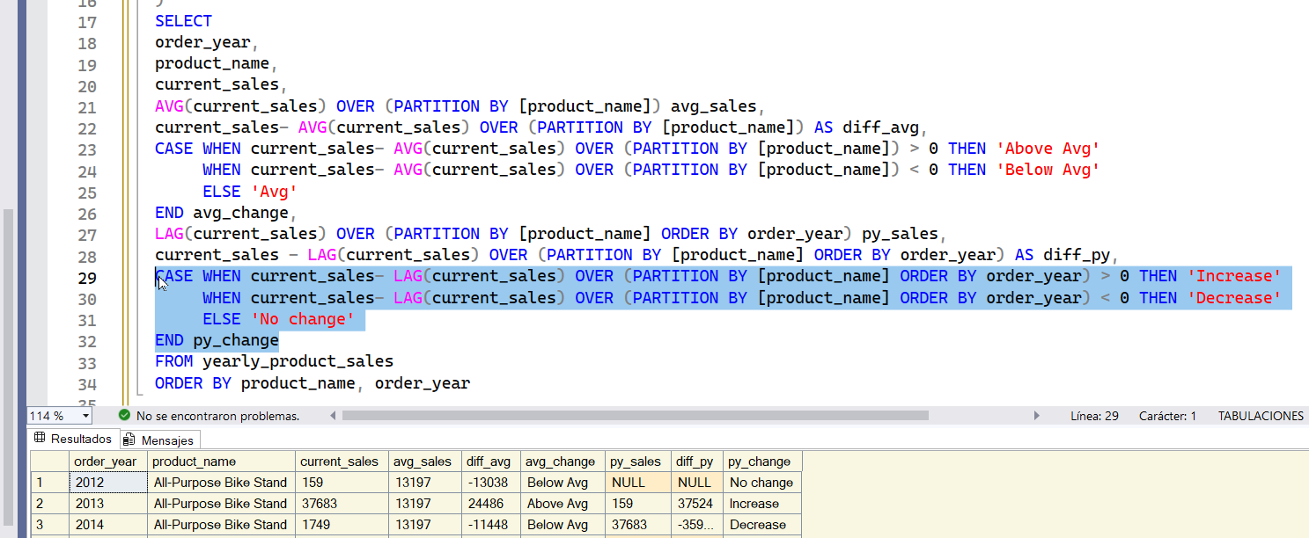

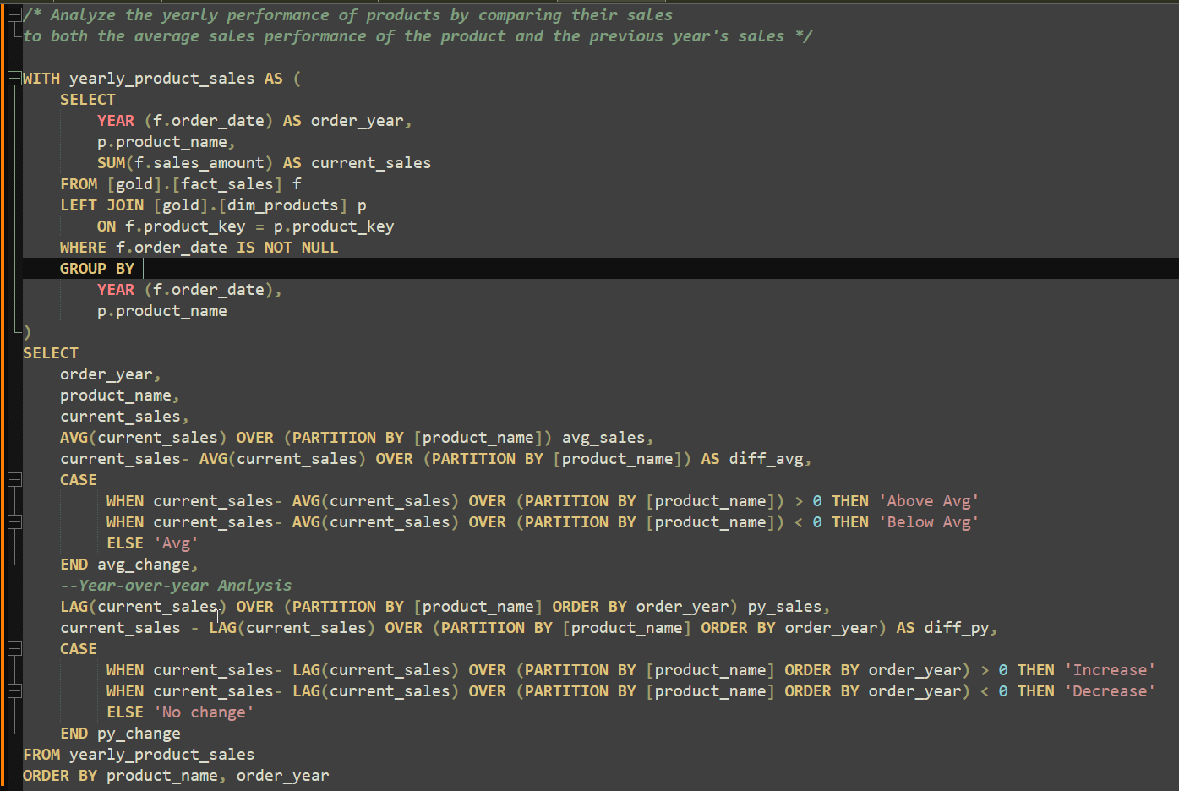

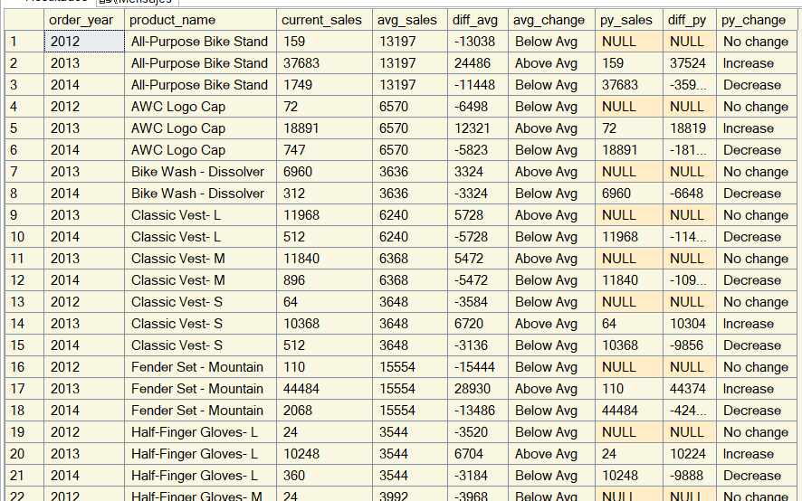

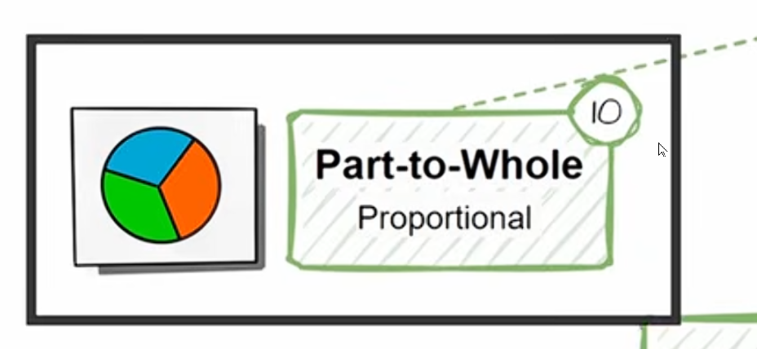



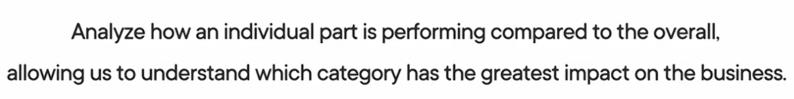

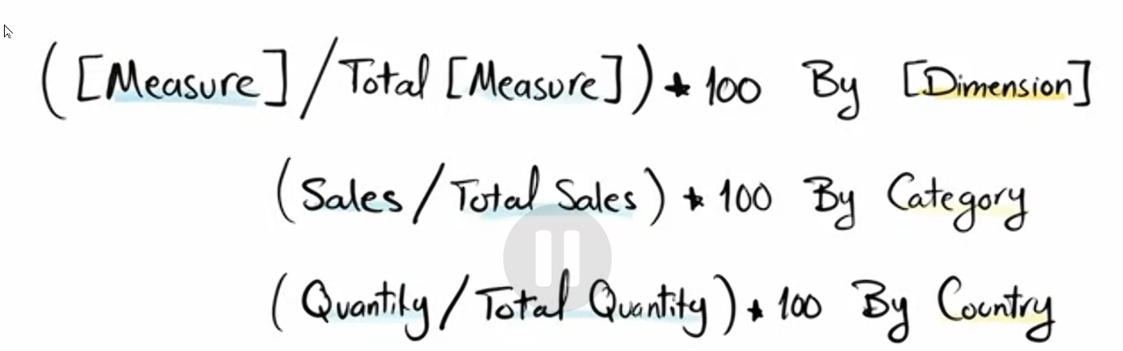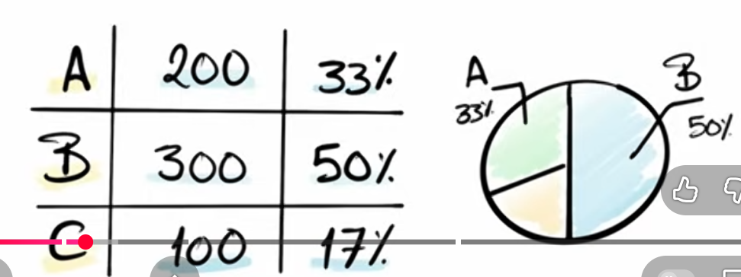



/\*

===============================================================================

Part-to-Whole Analysis

===============================================================================

Purpose:

- To compare performance or metrics across dimensions or time periods.

- To evaluate differences between categories.

- Useful for A/B testing or regional comparisons.

SQL Functions Used:

- SUM(), AVG(): Aggregates values for comparison.

- Window Functions: SUM() OVER() for total calculations.

===============================================================================

\*/

-- Which categories contribute the most to overall sales?

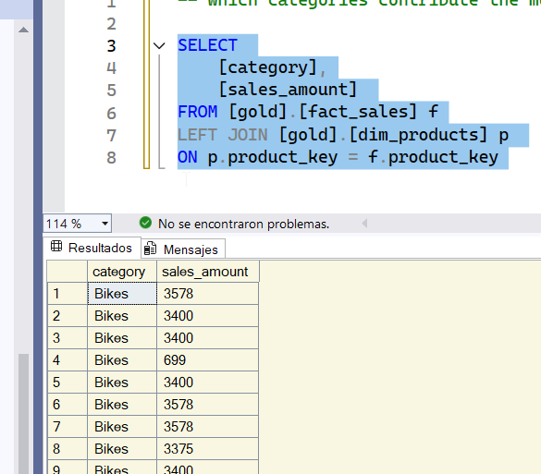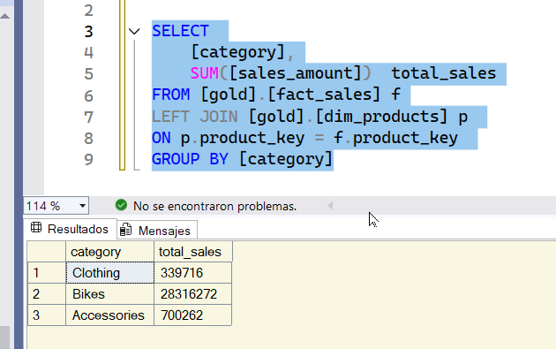

now we need the total sales by diff granularity

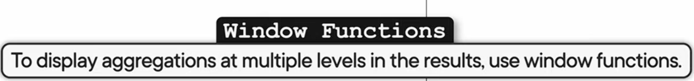

podes usar CTE or subquery

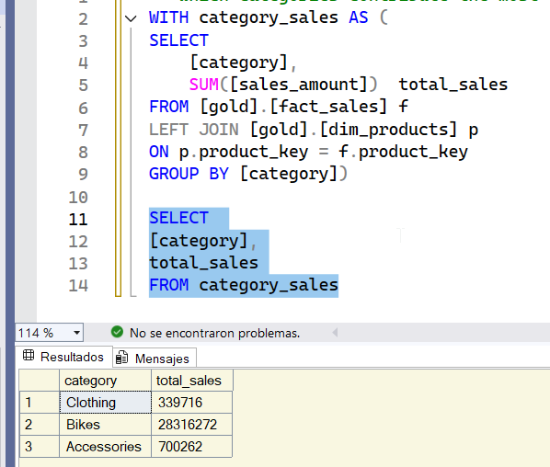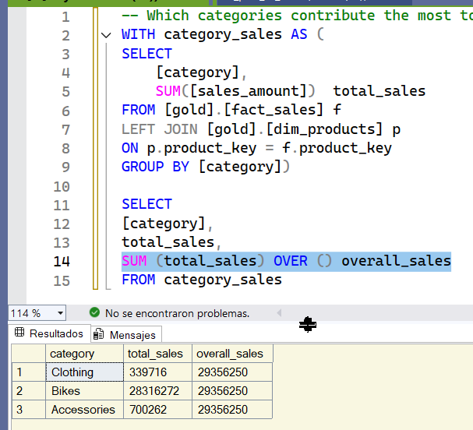

Now we are going to build our wx fx

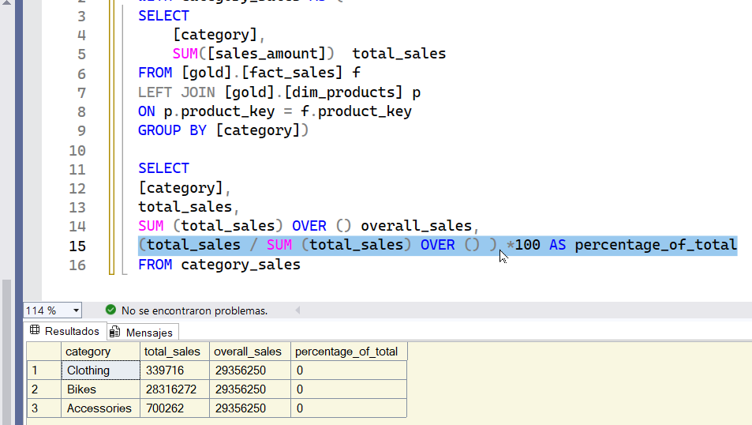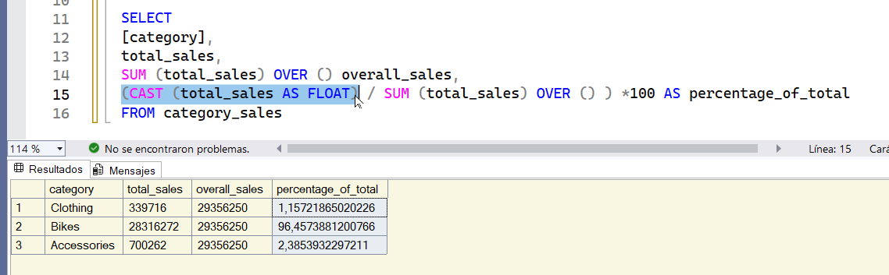

we get 0% bcs total sales is not float we have to cast it.

now we have to round the numbers now

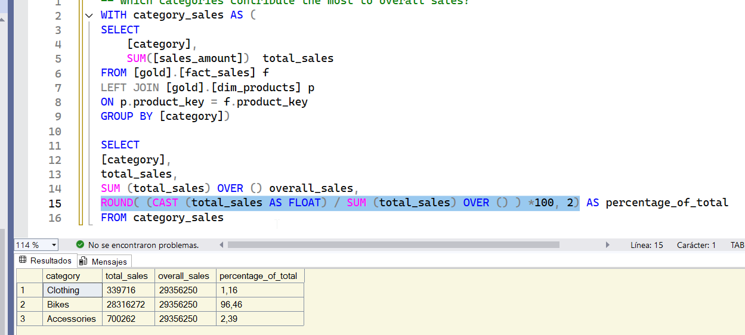

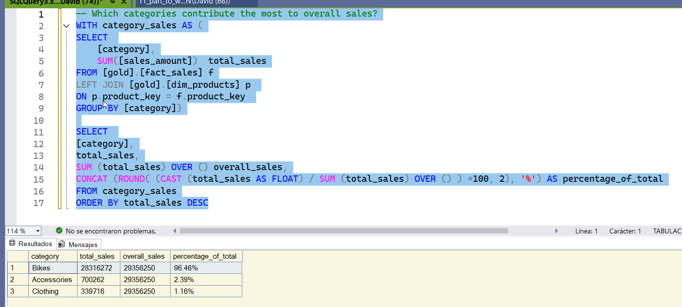

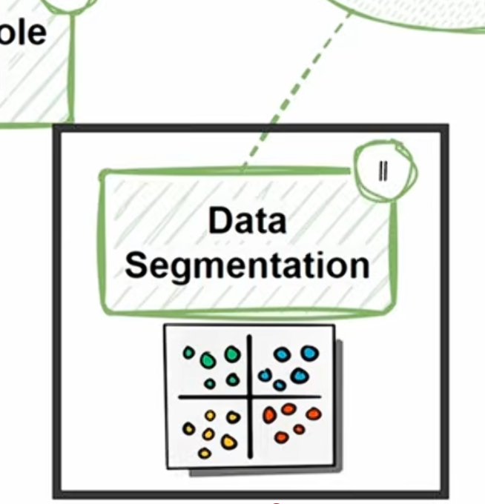

/\*

===============================================================================

Data Segmentation Analysis

===============================================================================

Purpose:

- To group data into meaningful categories for targeted insights.

- For customer segmentation, product categorization, or regional analysis.

SQL Functions Used:

- CASE: Defines custom segmentation logic.

- GROUP BY: Groups data into segments.

===============================================================================

\*/

/\*Segment products into cost ranges and

count how many products fall into each segment\*/

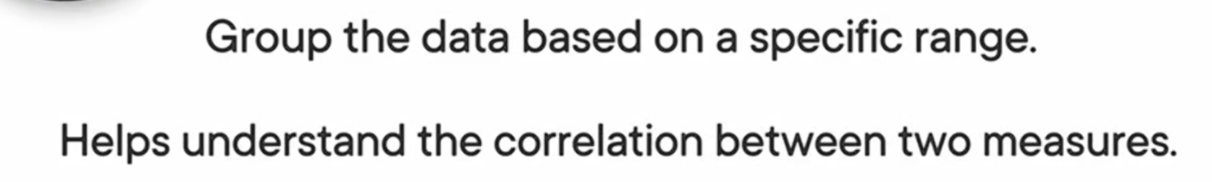

you have 2 measure and you have t convert one of those measure into a range or to a group and aggregate the data by this measure.

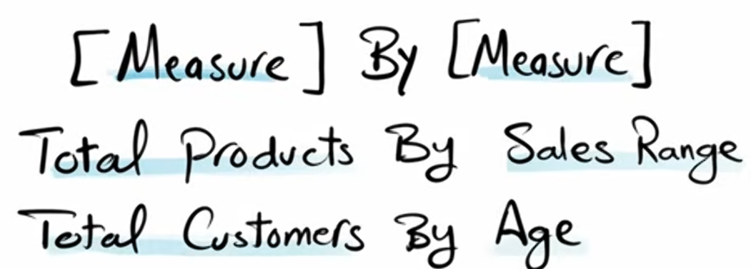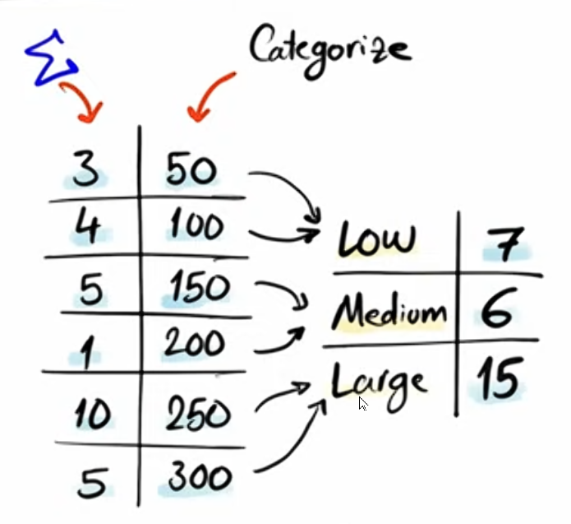

we are taking a measure and based on the range of this measure

we are building a new category a new dimension.

We use case when bs is going to help us define the rules

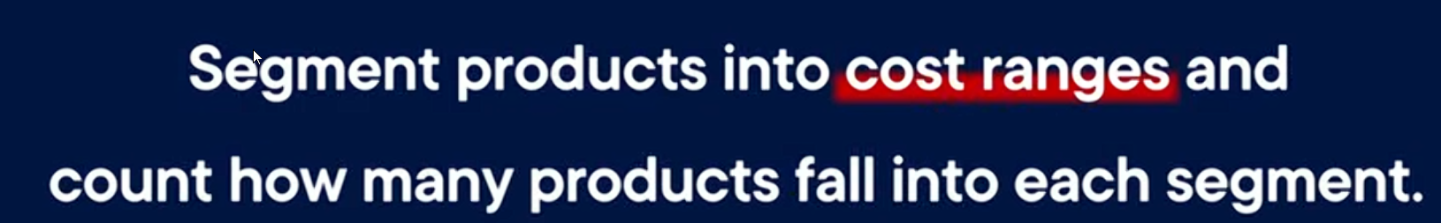

we have 2 measures 1 the cost 2nd total nr of products . We are segmenting the cost. We take this measure and convert it to dimension. We NEED to convert this measure into dimension. We use the case when statement.

2measures. 1 cost 2 total nr products

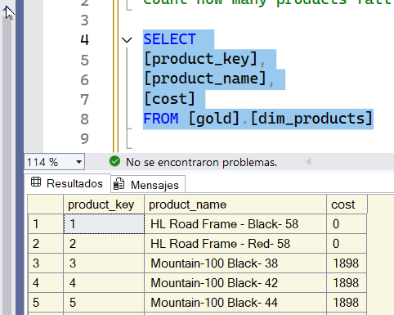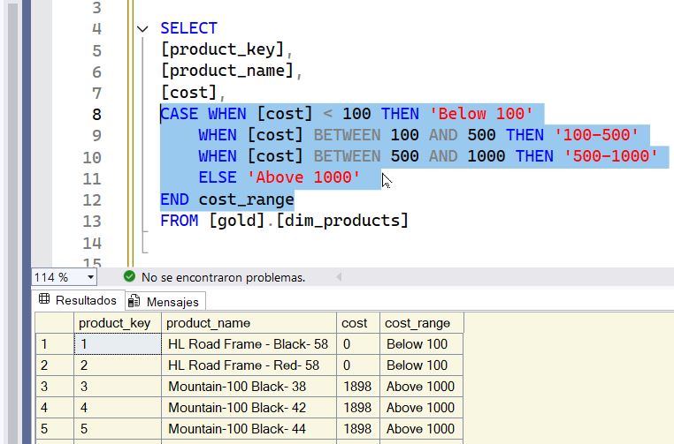

THE COST IS OUR MEASURE . We have to convert this measure into dimension with the case when. We use the case when when you convert to a new category. We have converted 1 measure into a dimension. We have our segments. Now we are going to aggregate the data based on the new dimension. we use 1 CTE.

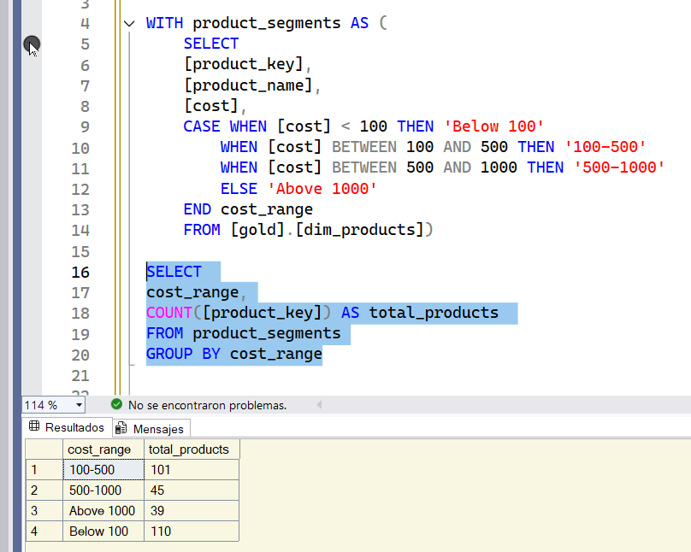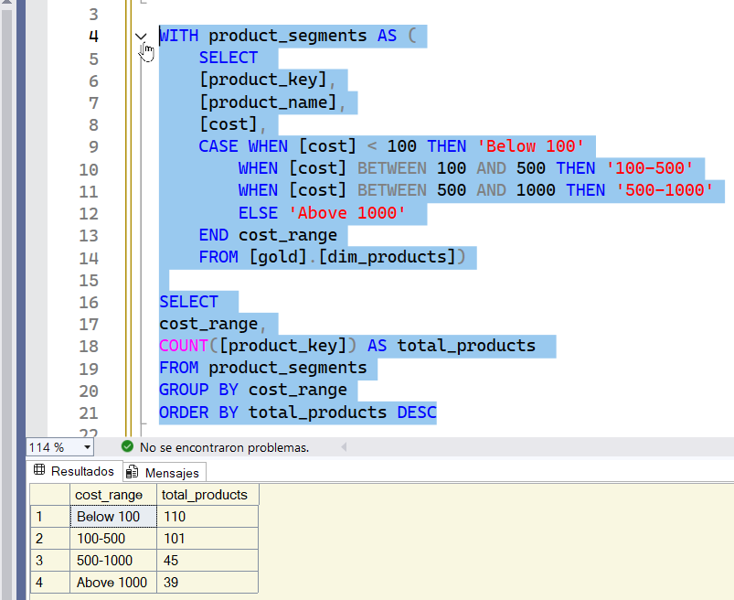

We have our segmented measure and we can see the total nr of segments in each range. We can order the data by our aggregation. We have a lot of products that cost below 100.



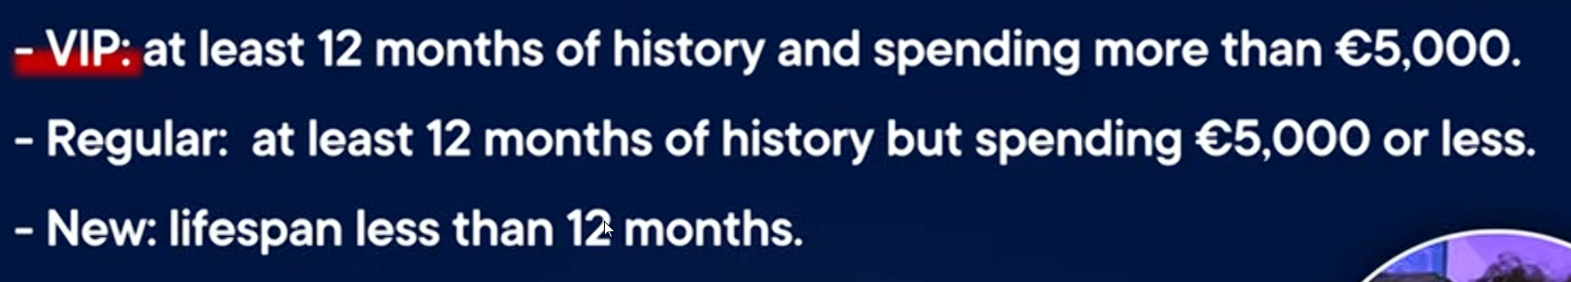



1 total nr of customers

we are going to build the segments.

1 first based on the measure

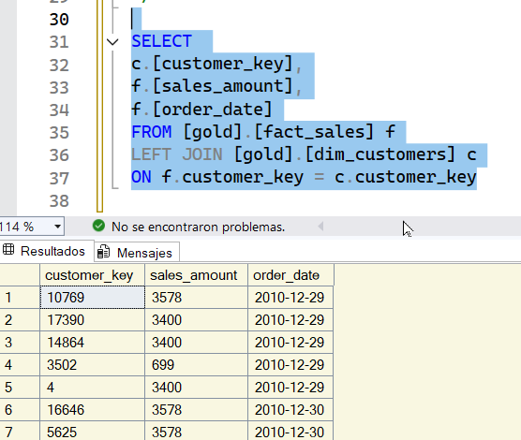

we are going to use the sales to specify the range of spending.

We have to calcuttae the lifespan. In order to do that we are going to need the first order and the last order of each customer. We use THE MIN function.

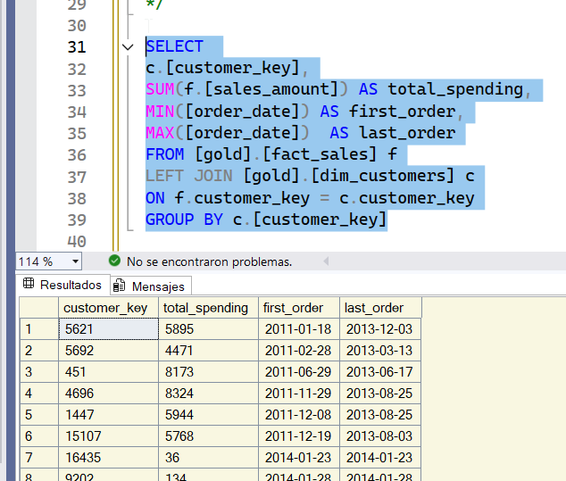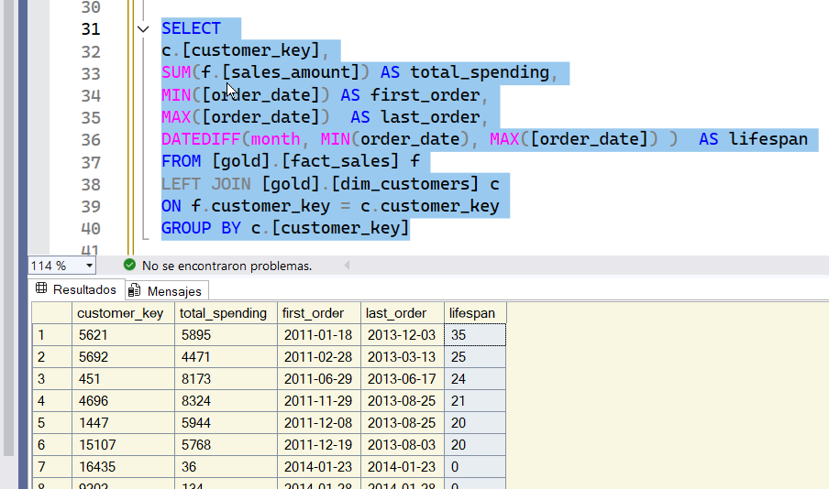

We can use the date diff. Now we are ready to start creating our segments.

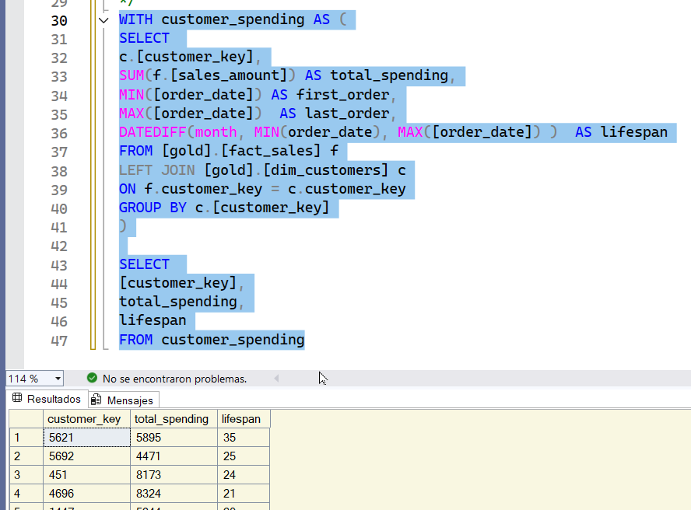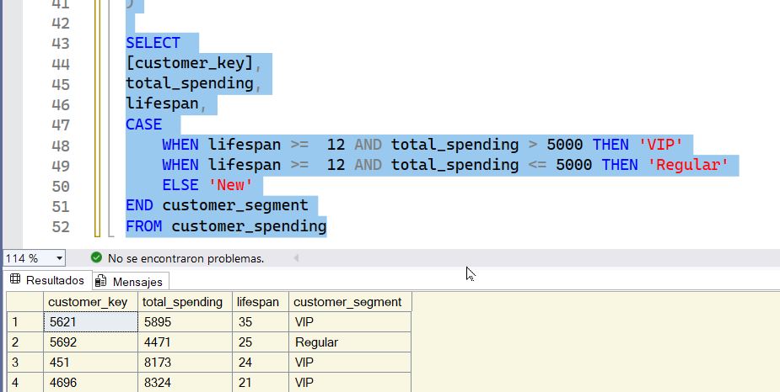

now we are going to build our segments. The last step is to find the total nr of customer for each of those categories

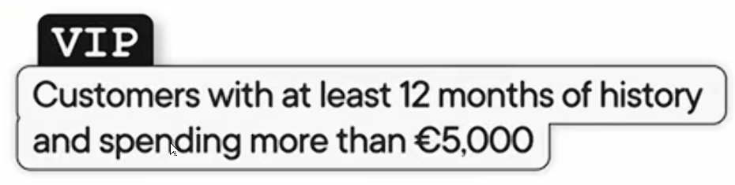

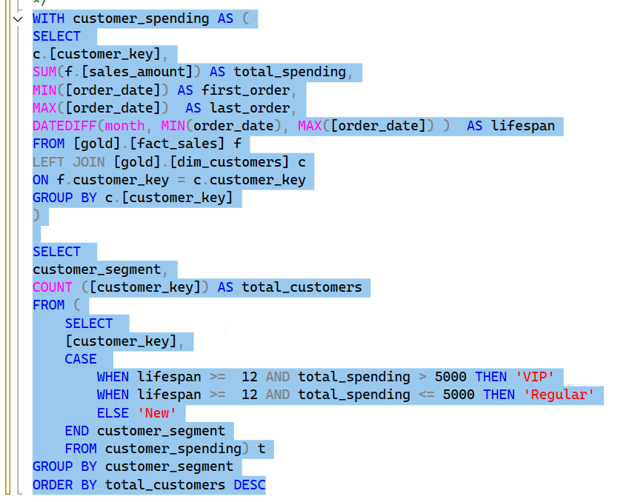

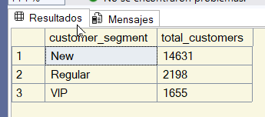

we have done data segmentation. We have segment our customer based on their spending behavior,.



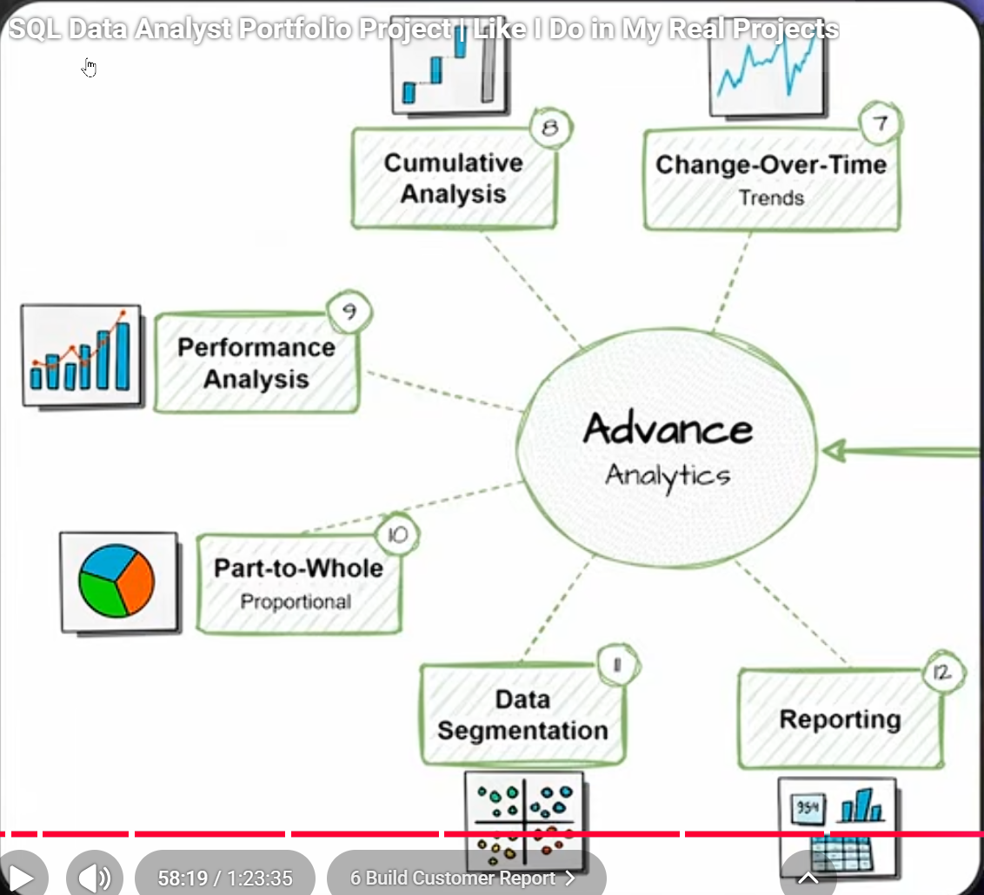

put everything in one big script

/\*

===============================================================================

Customer Report

===============================================================================

Purpose:

- This report consolidates key customer metrics and behaviors

Highlights:

1. Gathers essential fields such as names, ages, and transaction details.

2. Segments customers into categories (VIP, Regular, New) and age groups.

3. Aggregates customer-level metrics:

- total orders

- total sales

- total quantity purchased

- total products

- lifespan (in months)

4. Calculates valuable KPIs:

- recency (months since last order)

- average order value

- average monthly spend

===============================================================================

\*/

1 thing start selecting the data from the database. I usually start with the fact table then i joined with the dimension. then how to filter the data. In the result i will be selecting oly the relevant columns that i need for my report.

This step is called the base data. This is the foundation for the next steps.

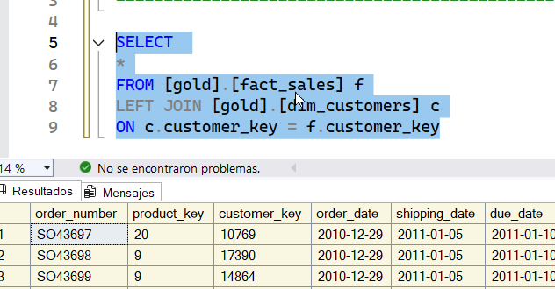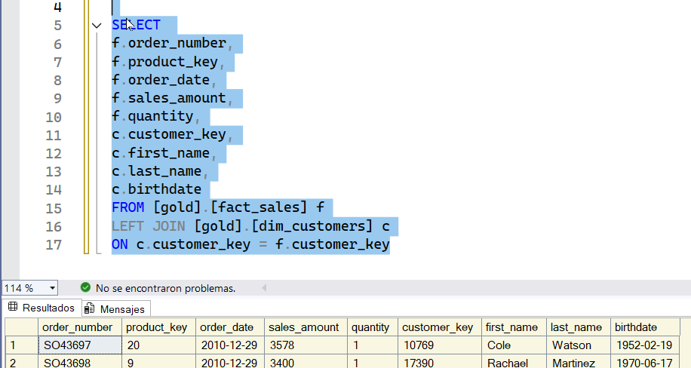

we are going to retrieve all the columns that we need. These are all the columns that we need to the next steps.

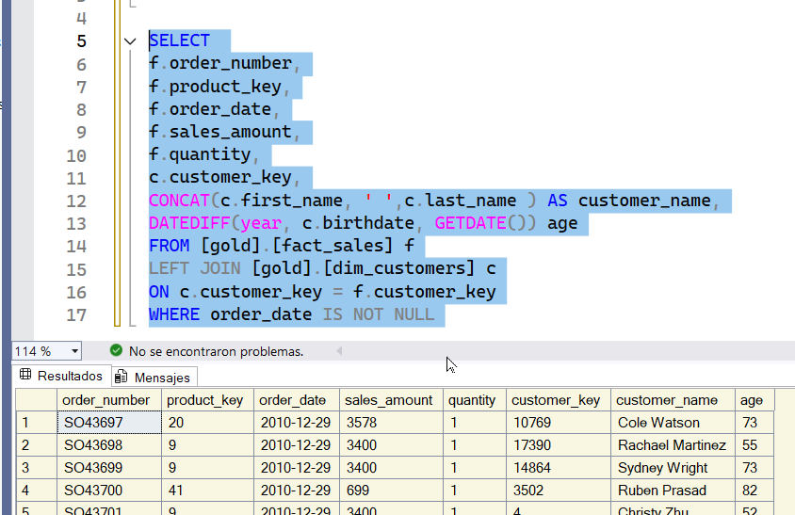 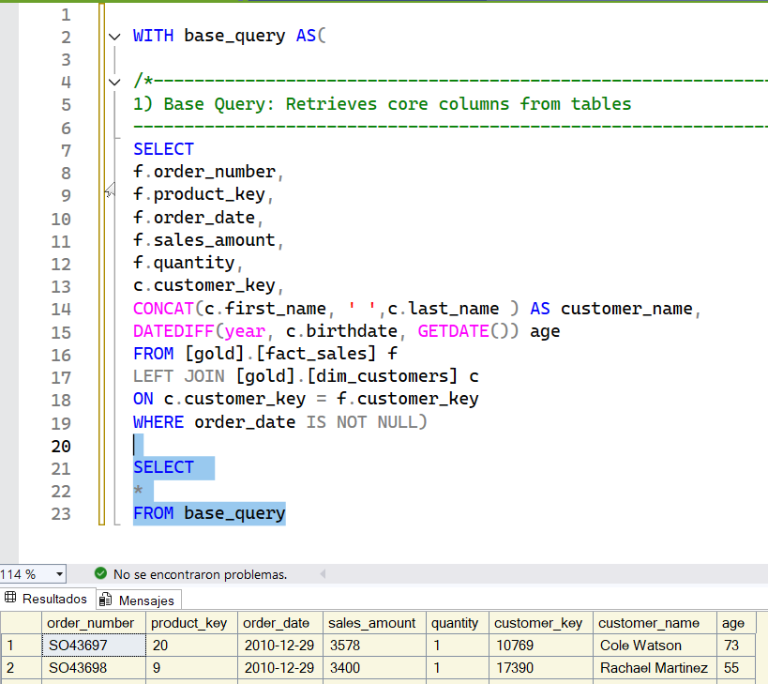

Now lets put everything on one CTE. Now lets write a query about our middle result.

NO we have our important columns. Next step we are going to do aggregation on top of these intermediate results.

Always make a separate CTE only for aggregations.

NOw we select our customer information.

3. Aggregates customer-level metrics:

- total orders

- total sales

- total quantity purchased

- total products

- lifespan (in months)

After that we are going to start doing aggregations. We are looking into our intermediate results and see what we can aggregate.

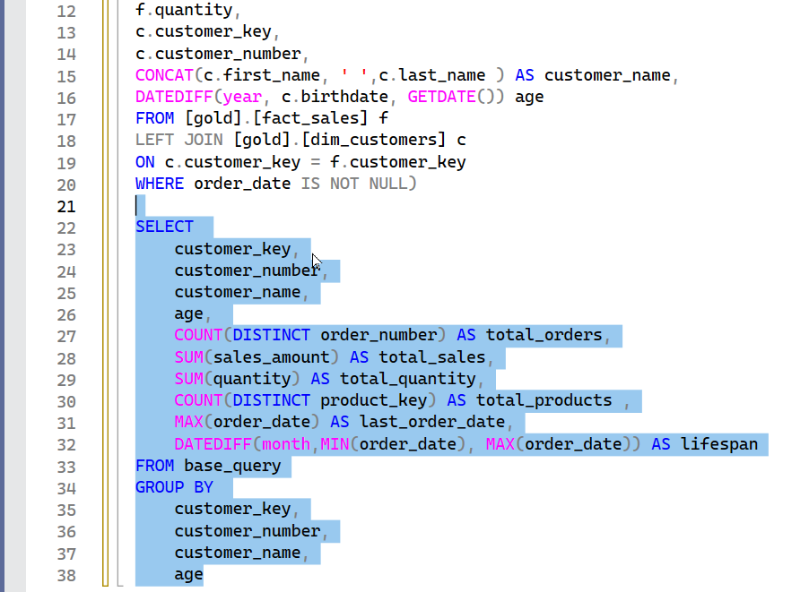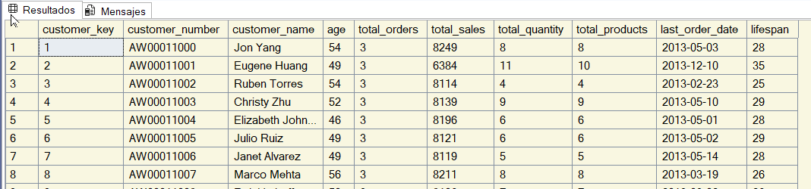

NOw we have provided aggregation on the customer level.

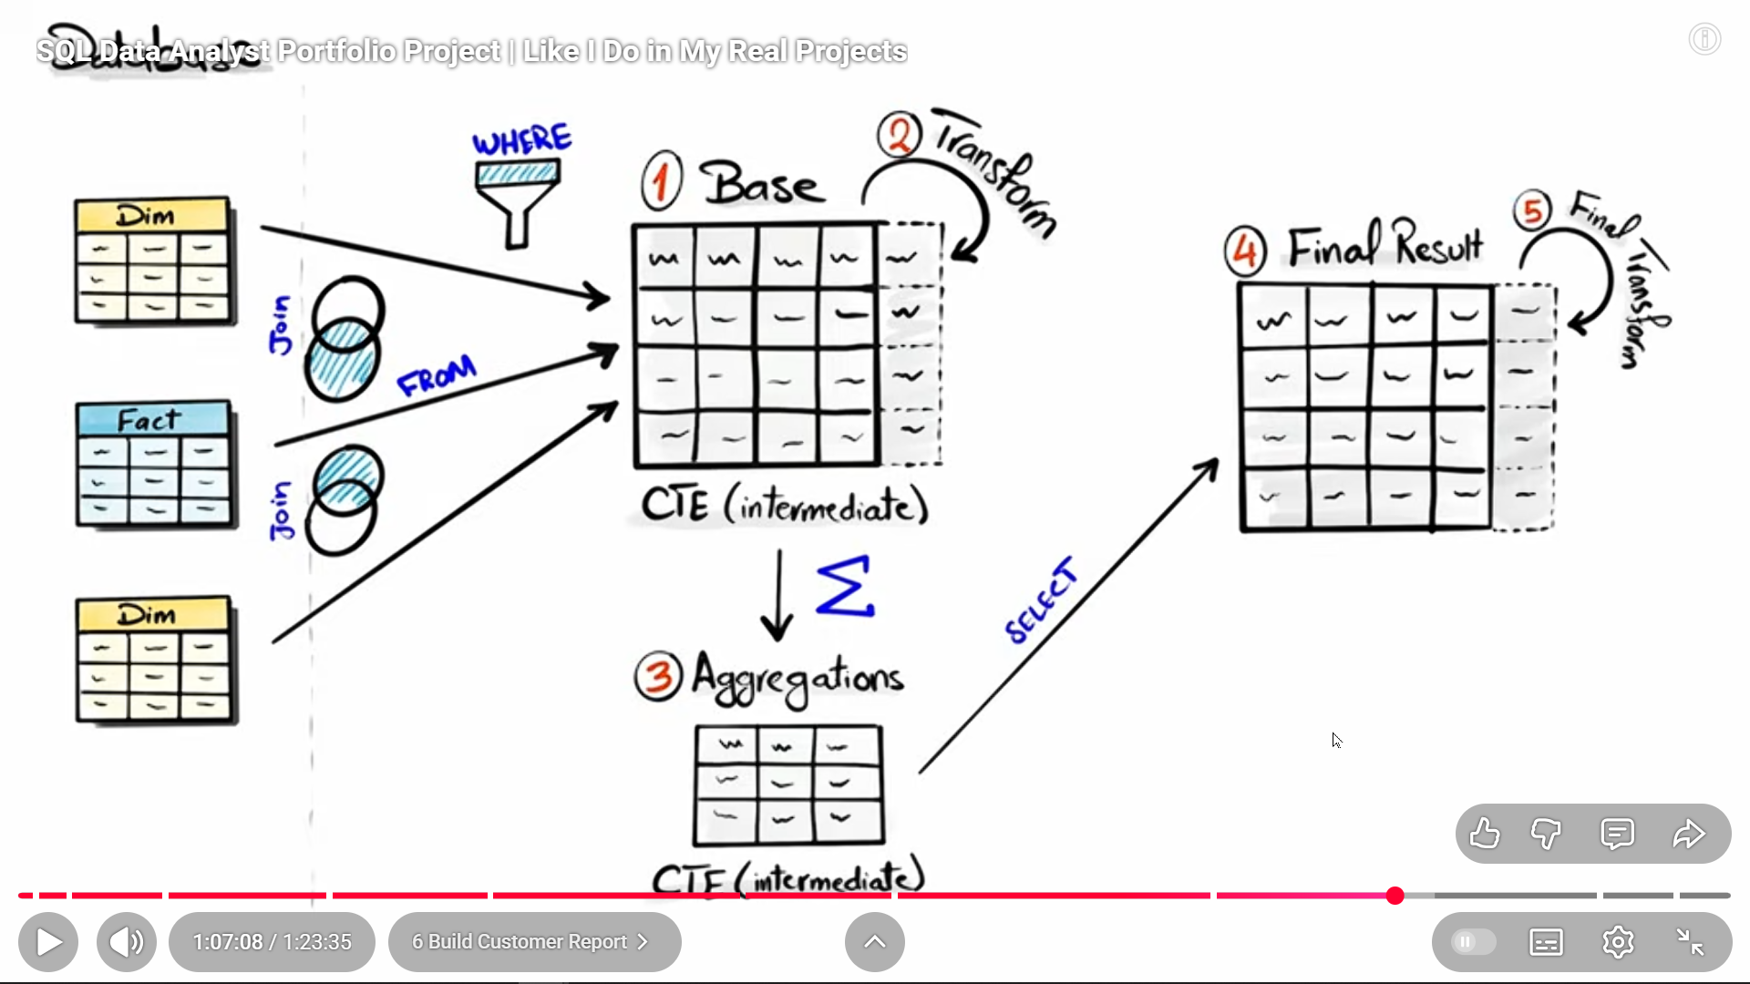

Now we can start segmenting our customer.

Based on this result we will write our final query. The first CTE is the base query. The 2 query is for the aggregation-.

We need to create the age categories.

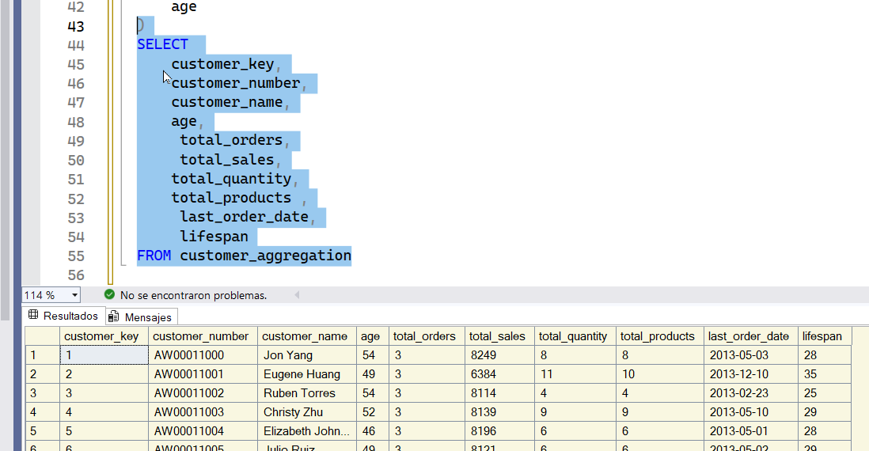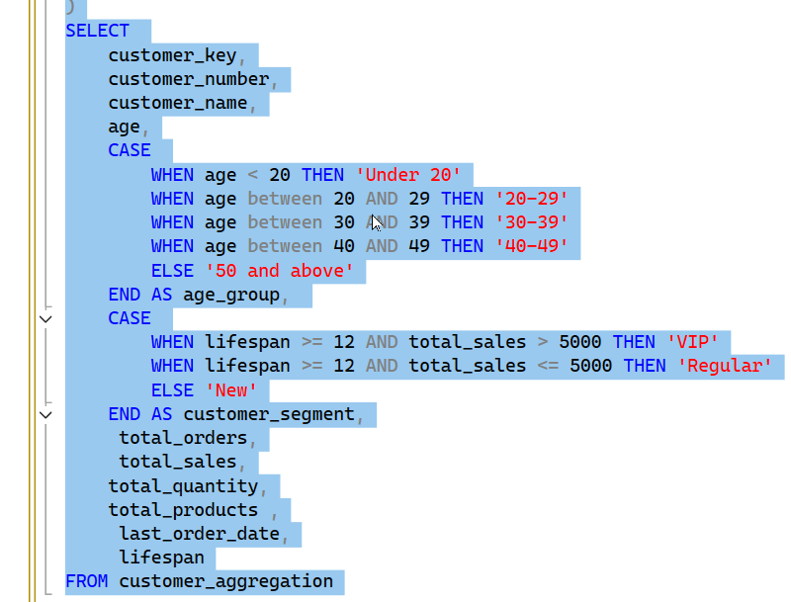

lets start with our last query. We have to create a few categories. And the segment for the customers. For segmenting the customers we have done the queries.

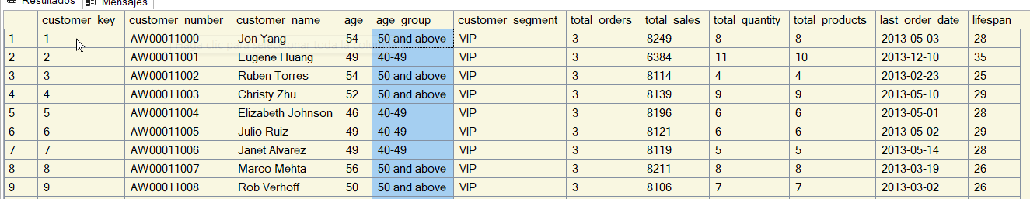

now we have to calculate the kpis

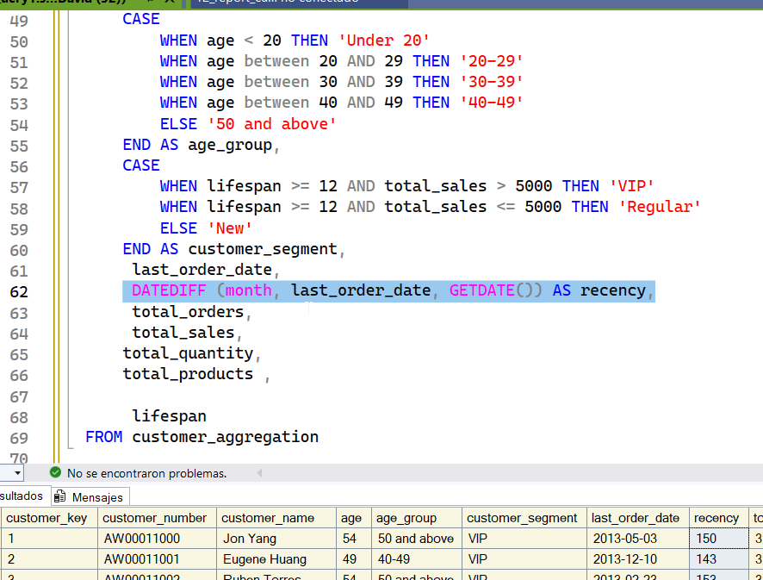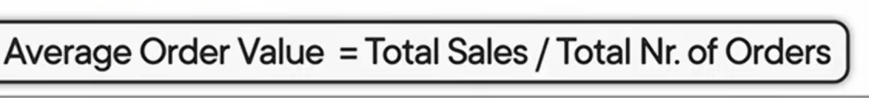

how many months since the last order customer.

- Compute average order value (AVO)

-- Compute average monthly spend

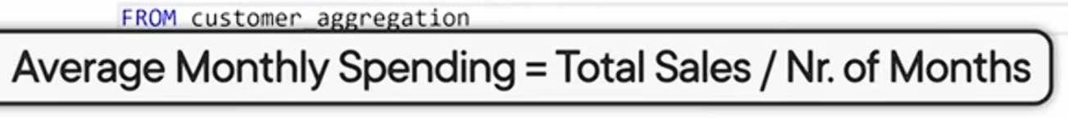

NOw we are going to put the entire query into a view. Now we can share it with others.



===============================================================================

Product Report

===============================================================================

Purpose:

- This report consolidates key product metrics and behaviors.

Highlights:

1. Gathers essential fields such as product name, category, subcategory, and cost.

2. Segments products by revenue to identify High-Performers, Mid-Range, or Low-Performers.

3. Aggregates product-level metrics:

- total orders

- total sales

- total quantity sold

- total customers (unique)

- lifespan (in months)

4. Calculates valuable KPIs:

- recency (months since last sale)

- average order revenue (AOR)

- average monthly revenue